Bash scripting Task 2

Bash Script Tasks
- Create a bash script to check if a directory is available or not.

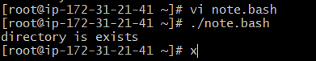
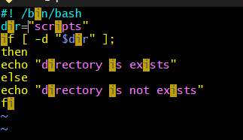

- Create a bash script to create multiple files.
- created vi multifile.bash. entered the bash script which we can be seen in the below screenshot.
- For changing permissions: chmod 755 multifile.bash. to execute command ./multifile.bash. files are created successfully.
- Use cat command to view the script cat multifile.bash
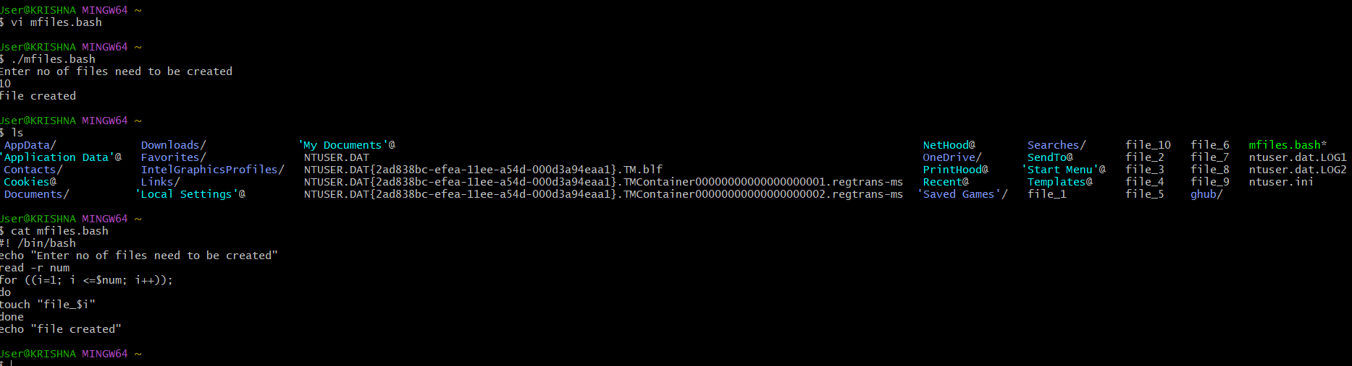

- Create a bash script to take a backup of a directory.
- Created an vi bdir.bash , used tar – cvf for compressing files .
- If statement is used to if exit status is equal to 0 it is successful, here 0 represents error in the execution.
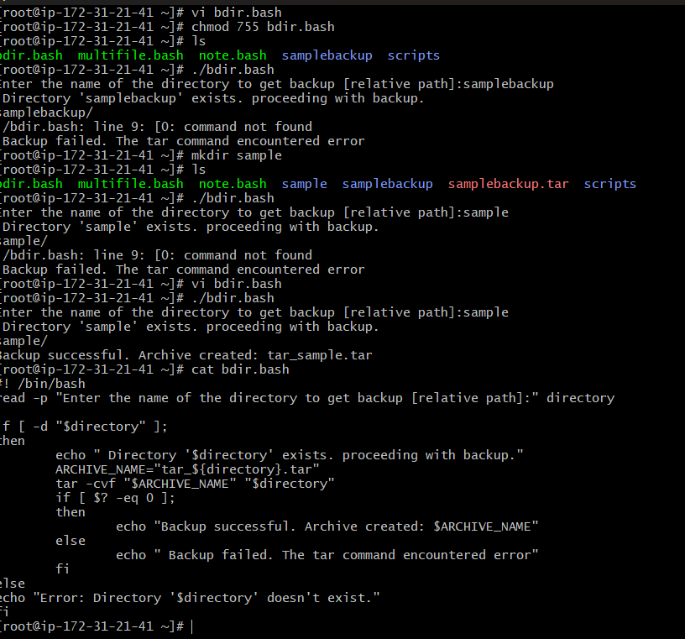
- Create a bash script to install Nginx on an EC2 server.
- To install nginx we use :
sudo yum update -y
Sudo yum install nginx -y
Sudo systemctl start nginx
Sudo systemctl enable nginx
Sudo systemctl status nginx
In the below image we can see that nginx is installed successfully.

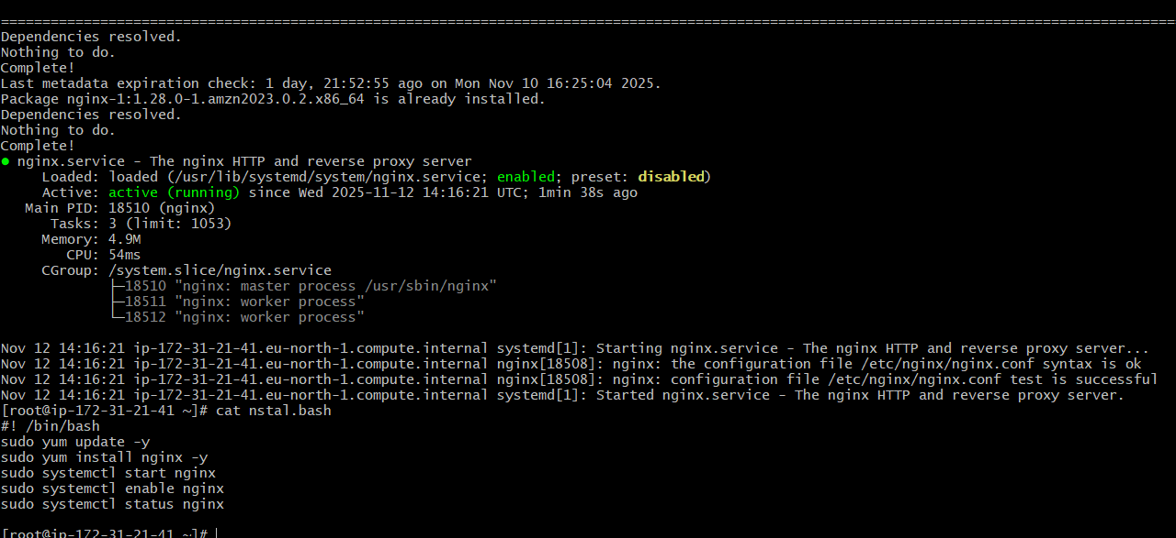
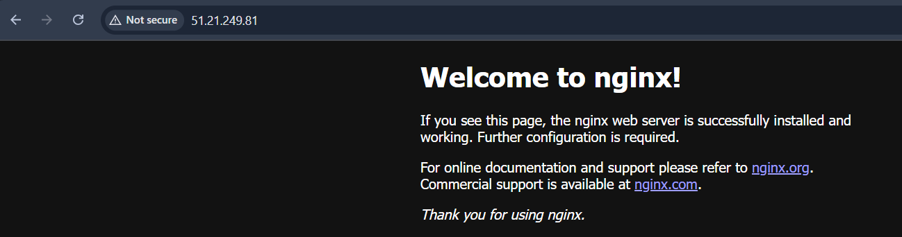

- Create a bash script to install Apache Tomcat on an EC2 server.
- I used below script to install apache Tomcat on ec2 server
#!/bin/bash
sudo dnf update -y
sudo dnf install java-17-amazon-corretto -y
java -version
sudo groupadd tomcat || true
sudo useradd -g tomcat -d /opt/tomcat -s /bin/nologin tomcat || true

cd /tmp
wget https://dlcdn.apache.org/tomcat/tomcat-9/v9.0.111/bin/apache-tomcat-9.0.111.tar.gz
sudo mkdir -p /opt/tomcat
sudo tar -xvf apache-tomcat-9.0.111.tar.gz -C /opt/tomcat --strip-components=1
sudo chmod -R 755 /opt/tomcat
cat <<EOF | sudo tee /etc/systemd/system/tomcat.service
[Service]
Type=forking
User=tomcat
Group=tomcat
Environment="JAVA_HOME=/usr/lib/jvm/java-17-amazon-corretto"
Environment="CATALINA_PID=/opt/tomcat/temp/tomcat.pid"
Environment="CATALINA_HOME=/opt/tomcat"
Environment="CATALINA_BASE=/opt/tomcat"
ExecStart=/opt/tomcat/bin/startup.sh
ExecStop=/opt/tomcat/bin/shutdown.sh
RestartSec=10
Restart=always

[Install]
WantedBy=multi-user.target
EOF
sudo systemctl daemon-reload
sudo systemctl enable tomcat
sudo systemctl start tomcat
sudo systemctl status tomcat
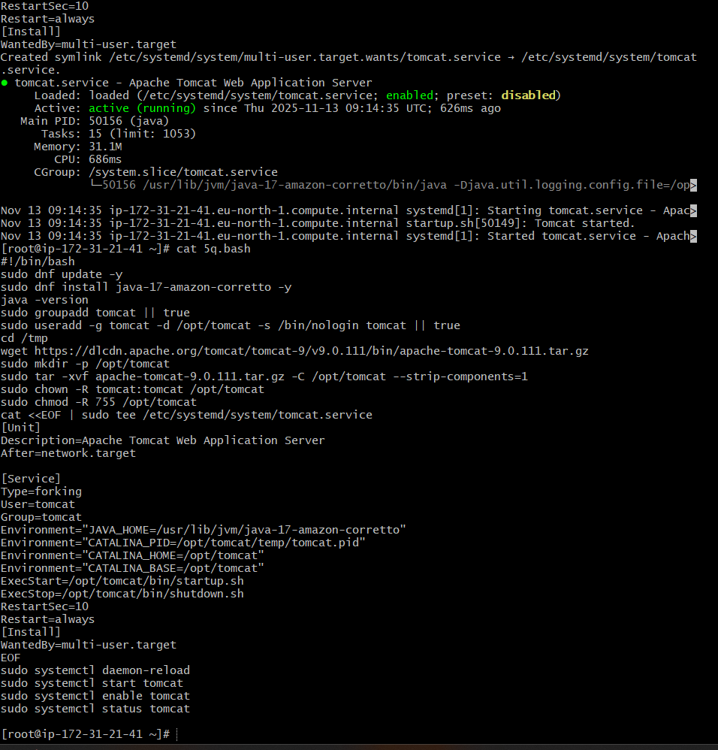

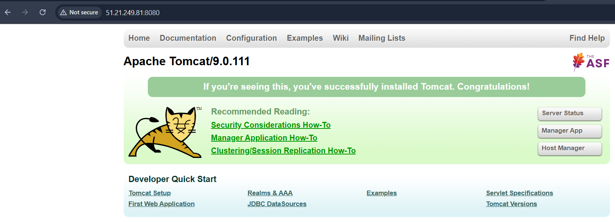

- Create a bash script to check if the Nginx service is running, if not running then script should start the service.
- Using this command we can whether nginx is are not systemctl is-active –quiet nginx

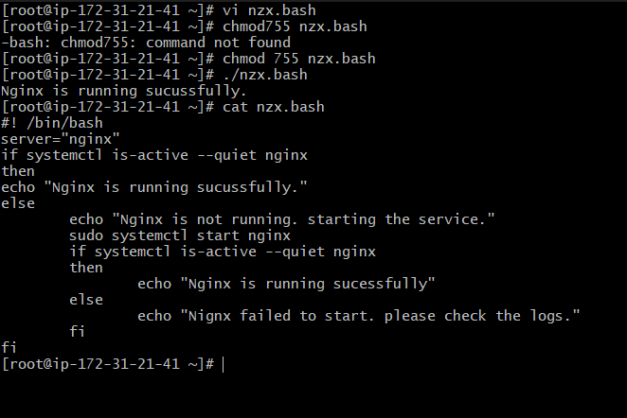

- Create a bash script for a calculator.
- In this we use arithmetic opaterors and using case we create basic calculator

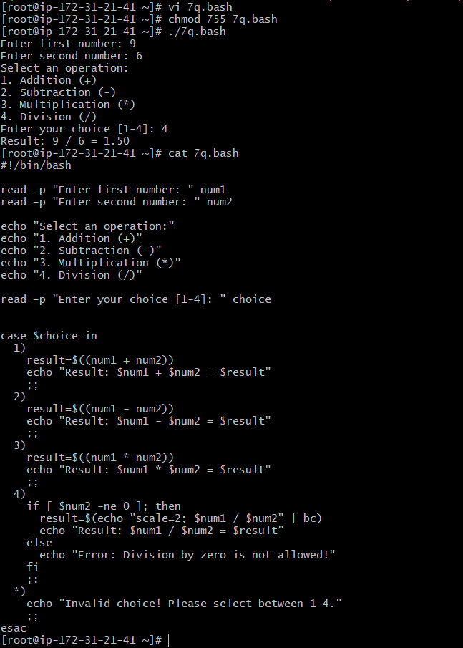]\

- Create a bash script to check if a directory exists, if not then create a directory.

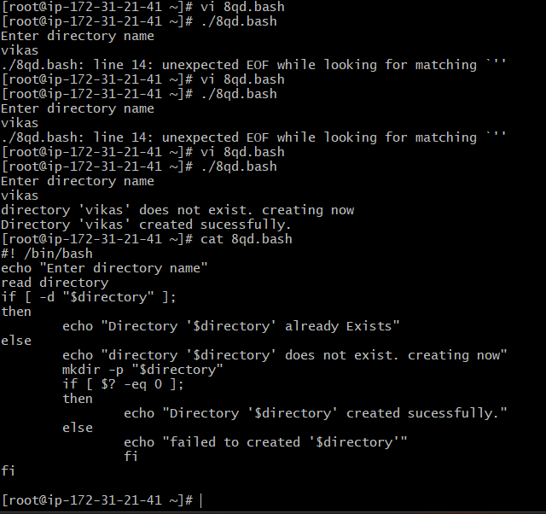

- Create a bash script to delete the last 3 lines of a file.
- In this script we use head -n -3 “filename” > means it prints everything except the last 3 lines.
- Mv temp_file filename which replaces original file with the new file
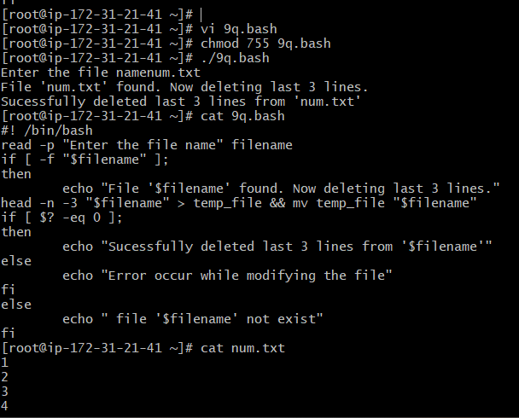

- Bash script to monitor cpu and if it is more than 80% then send email notification.
- In this script top -bn1 means run top command once in batch mode and grep “cpu(s)” is used to pick the cpu line
- $8 = idle % → example: 3.0 . we do this to know current cpu usage 100 - idle > gives CPU→ 97%
- cut -d'.' -f1 > To remove decimal
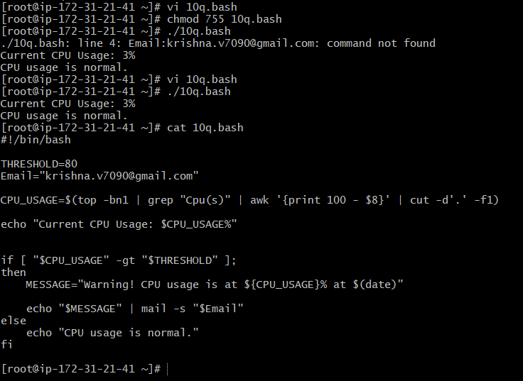
- Bash script to monitor disk space and if it is more than 80% then send email notification.
- We use df –output=pcent / to see disk % of the root / filesystem
- Tail -l is used to take last line
- Tr -d ‘ %’ to remove space and %symbols
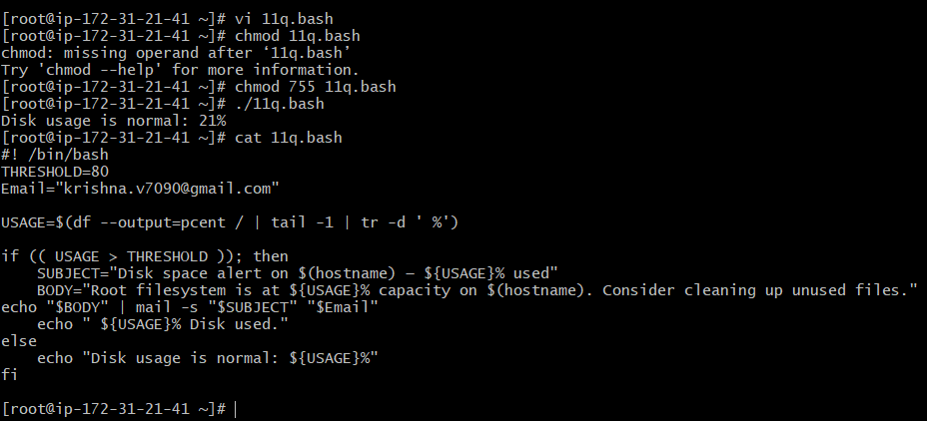
- Bash script to monitor memory and if it is more than 80% then send email notification.
- We use grep mem to pick the line containing mermory totals
- $ 3 it is used memory and $2 is total memory. It is used to calculate percentage of use ($3/$2)*100
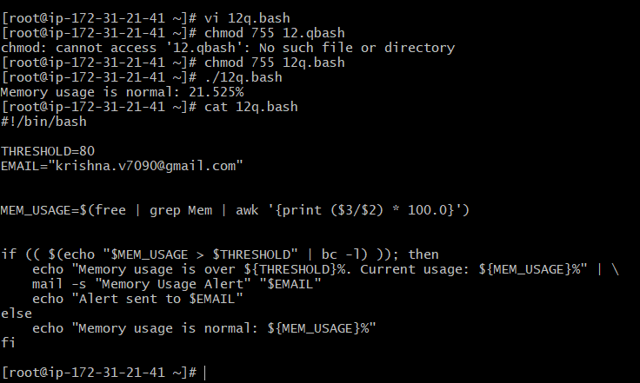

Exercise: Crontab Entries
- April 5th Midnight
- 5th of Every November, January, June if it is a Thursday
- At 05 and 27th minutes of 9, 10, 11 hours every day
- 34 minutes of 9th hour on 15th August
- Every midnight
- Every Weekend (Saturday night 11:59 PM)
- After every reboot

* * * * * command
│ │ │ │ └─── Day of week (0–6) 0=Sunday
│ │ │ └───── Month (1–12)
│ │ └─────── Day of month (1–31)
│ └───────── Hour (0–23)
└─────────── Minute (0–59)

